Red Team - Outland Adventures Database Project

Team Members
Matthew Rozendaal
Mickelly Audam
Tiffany Davidson

Case Study Selected
Outland Adventures

Key Business Decision Reporting Datasets (outland_adventures.py)
#1 (Trip and Booking)
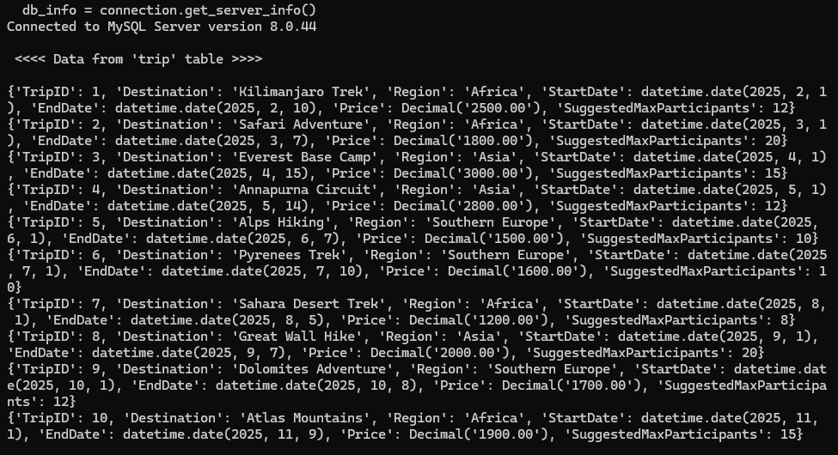

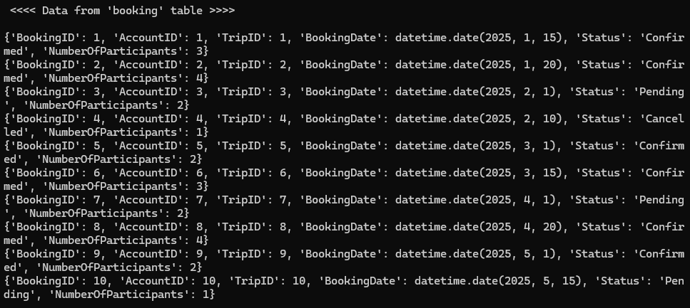

#2 (Equipment and EquipmentTransaction)
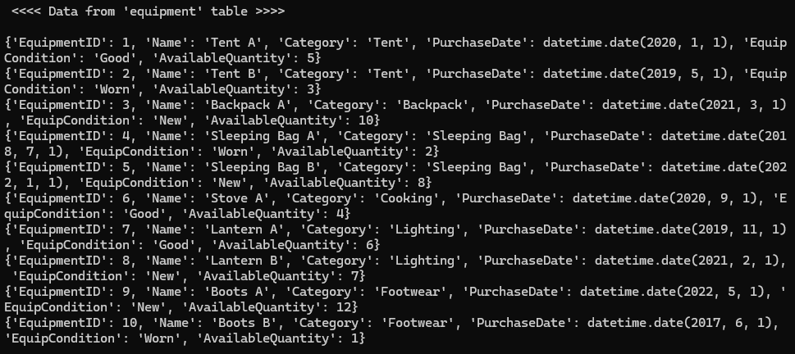
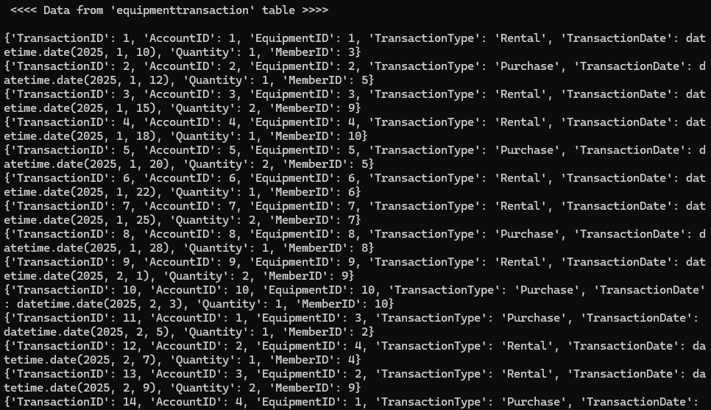

#3 Joined Datasets (Trip and Booking)
